Using the High School Graduation & College Going Tool

The purpose of this tool is to promote a common understanding of the current state of high school graduation and college going outcomes, as well as the factors that impact those outcomes, and to generate a plan for improving those outcomes.
The tool allows the users to define the location(s) to be examined so the data are relevant to the user.
You can go through the screens in order, or just view selected screens to answer a specific question such as how do our schools compare to other Arizona high schools or what is the education level of people in the school’s community? That allows the audience to absorb and discuss the information one topic at a time.
The data represents specific graduating classes. So far, we have the Class of 2016, the Class of 2017 and the Class of 2018 (once quality assurance testing is complete). We want the data to reflect that cohort’s experience as closely as possible.
However, more recent test scores and graduation rates are available. Some people will want to look at those as well as the data in this application to see if a school is still performing similarly. We have created visualizations in which schools are listed by free and reduced lunch rate, so you can easily benchmark them to comparable schools. We are posting these files on our website at decisioncenter.asu.edu/tools/.
You can navigate through the screens by clicking on the selection criteria (top left) to go to the selection screen you are interested in. You can also drag the bar at the bottom of the screen across and you will see the screens in order. If you want to make the image bigger click control and +, and to make it smaller control and -.
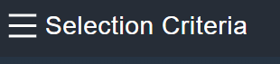
Click on the three lines in the top left to choose the screens
The tabs above lead to each of the seven screens:
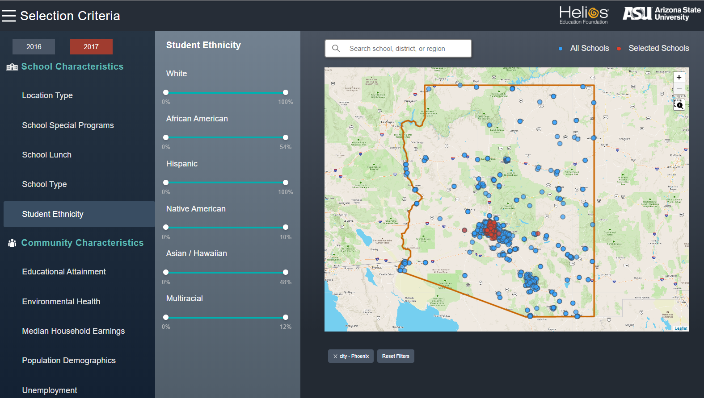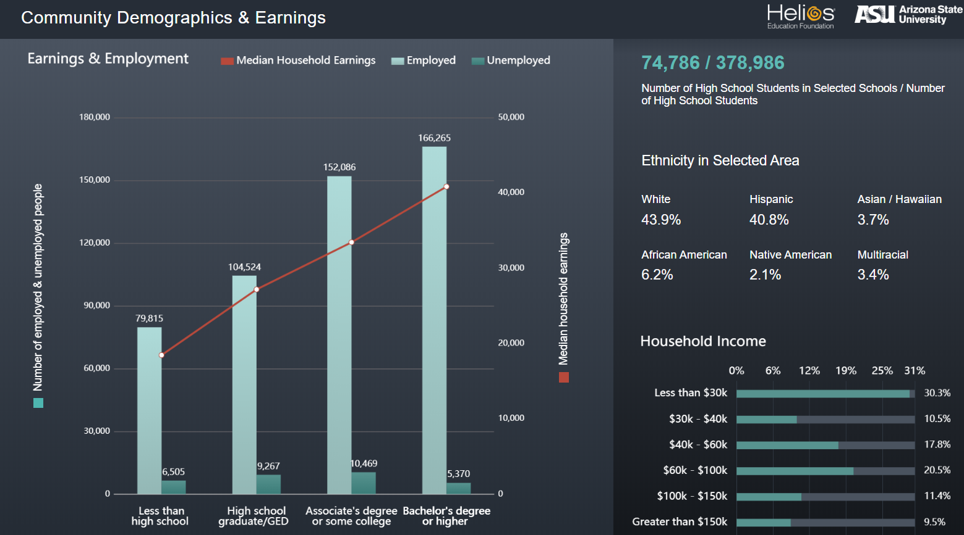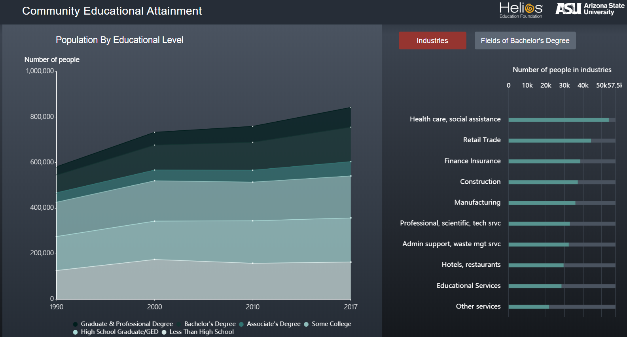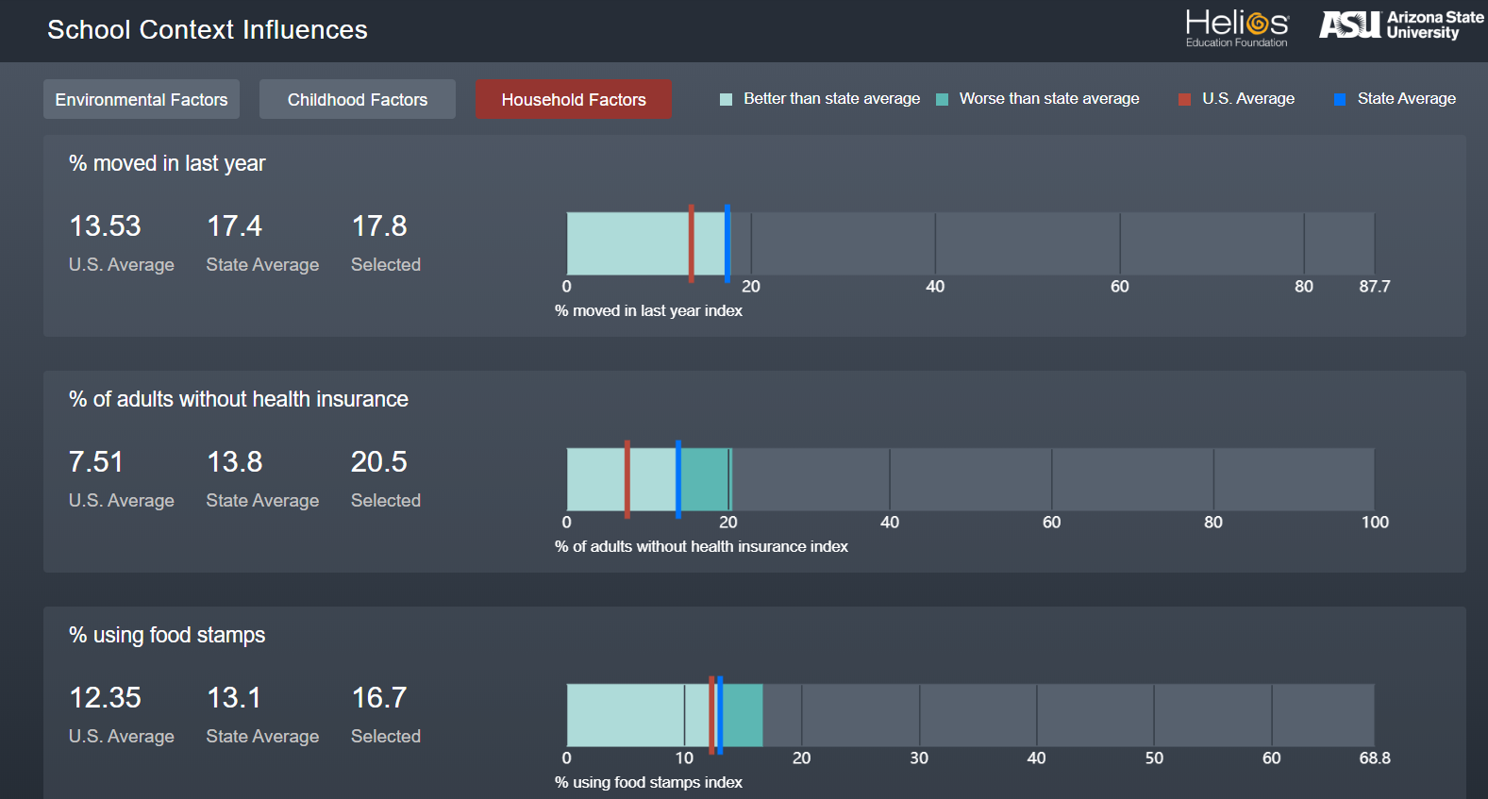
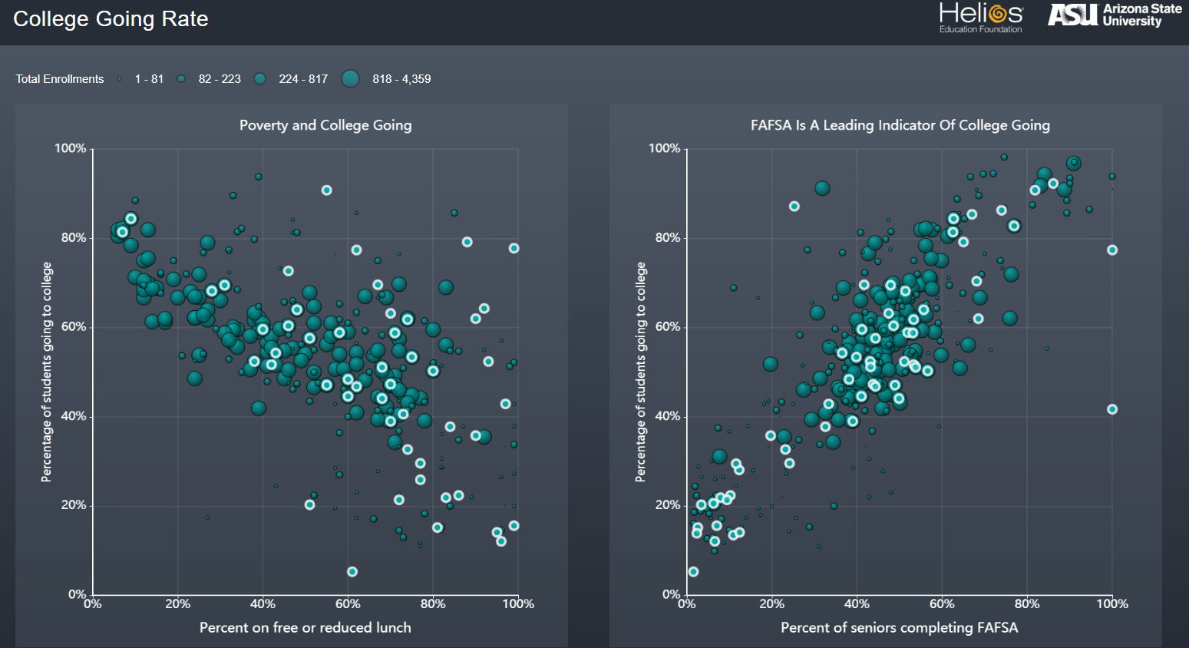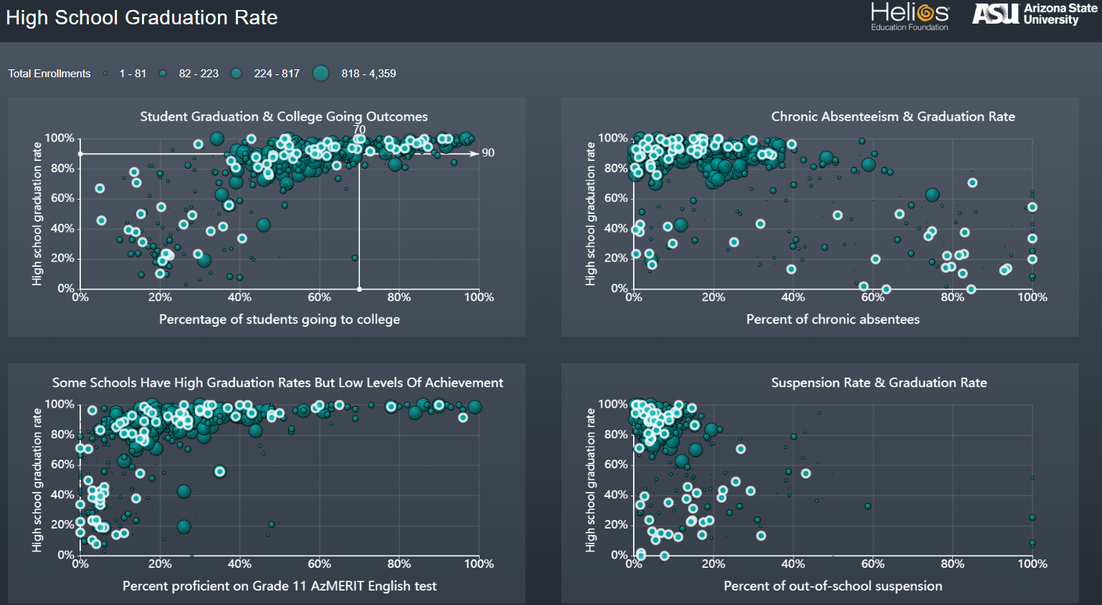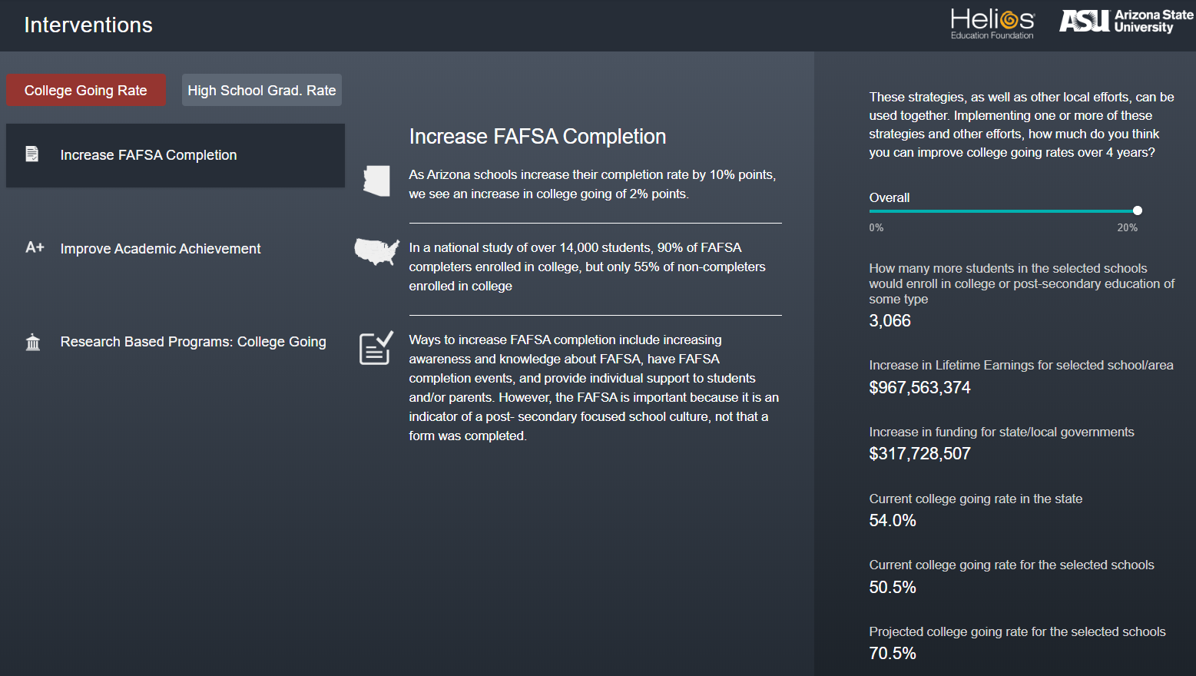
Step 1: Select the location or locations you want to focus on. This can be a town, school, school district, type of school, or schools that share a similar demographic such as having 50% Hispanic or 75% on free or reduced priced lunch. Also, choose the “Class of” (2016, 2017, 2018) that you want to examine. Additional classes will be added once all the census and other data for a class year has been released, often 18-24 months after graduation (see note on page 2 for more details).
Once you have chosen a focus, all the remaining screens will reflect that choice.
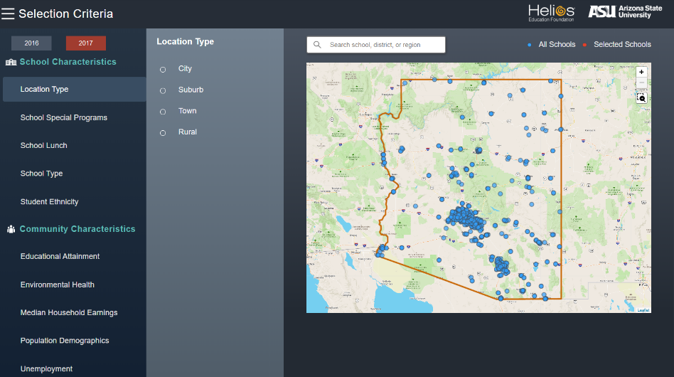
You can choose a school characteristic, a community characteristic and/or a location type. Click on the characteristic you want to choose on the left and then your options will appear to the right, and you use the radio buttons or slider to make your selection.
You can also type in the white box the name of a city, county, school, district or ‘alternative’ to choose those options.
If you choose more than one characteristic you will see the school(s) that meet both characteristics.
It is recommended that you choose your school or location first. Once you have seen your demographic characteristics you may want to see how your school(s) compare to other schools. Use this screen to select similar schools or community characteristics. You can always come back and change your choice as often as you wish. For example, you may want to just look at a specific school’s community characteristics and then add additional schools by choosing similar populations (e.g., schools with 25% or more Native students) or poverty rates (e.g., free lunch between 30% to 50%) to the filter so they are highlighted on the benchmarking slides. Just add characteristics or click on reset filters at the bottom of the map and then add a new set of filters.
Step 2: Define what you want to look at during this session. The screens cover demographics and earnings, educational attainment, school context variables, college going, high school graduation, and interventions to improve student outcomes. If you have the time you can review all of the screens. However, each screen can generate a great deal of discussion so you may want to use just a couple of screens per meeting. Think about what you are trying to accomplish, the audience’s comfort with statistics, and the time available when planning how you will use this tool.
Click on the three lines in the top left to choose the screens
The content of the seven screens
Step 3: What are the characteristics of the communities around the school that may impact outcomes? Your strategies and focus for improving high school outcomes may differ depending on the community characteristics. For traditional schools, the community is the area within the attendance boundaries of the school. For a charter school, it reflects the immediate neighborhood (census tract) in which a school is located because students can come from anywhere.
The first screen that gives you insight into the community in which a school exists is the demographics and earnings slide.
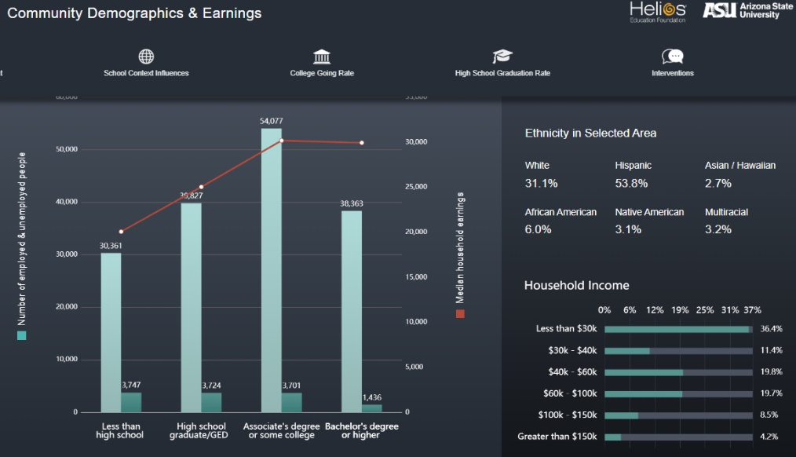
On the left of this screen you see the educational attainment of the adults in the area by less than high school, high school graduate, some college or Associates degree (mostly some college and no degree), and BA and higher. This is important because parents who have not attempted or completed college may not know how to navigate the college application and scholarship process, and thus students may need more help and guidance in the college search and application process.
This slide also shows the average household income for each attainment level as well as overall. In the lower right we see that almost half of the households in this example earn less than $30,000 or $30K to $40,000. These students may not think they can afford college or lower their sites to less expensive schools or community colleges. These students, if they are academically prepared, actually have access to the most financial aid and will need information and support to access it. In contrast, those making $50-80,000 may not qualify for need aid but have limited family resources to pay for college. Your strategies to increase college going will vary depending on the people in the community you are focusing on.
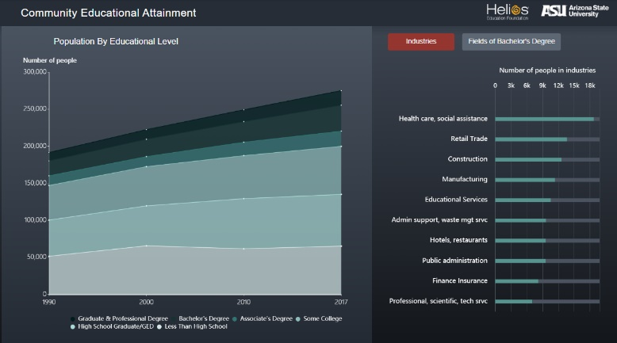
The other slide that shows you community characteristics is the community educational attainment screen. The graph on the left of the screen shows the change in population (the higher shaded area on the right reflects more people in the area). If you hover over the graph with your cursor you see the educational attainment of the community and the change since 1990. In many cases, the less than high school group has gone down and degree attainment has gone up (but not enough to get to the 60% attainment goal) and the ‘some college’ category is a large percentage of the community (20-40%).
On the right side is a list of the top 10 industries in the area. These are the jobs and careers students see when they look around their family and neighborhood. If there are limited high wage industries, one may have to work harder to show students career opportunities that they may not be aware of. This table toggles with a list of the BA or higher degrees of people in the area. This indicates the availability of role models and potential mentors in the area.

Step 4. School Context Influences -- Variables that Impact Education, but Schools Do Not Control.
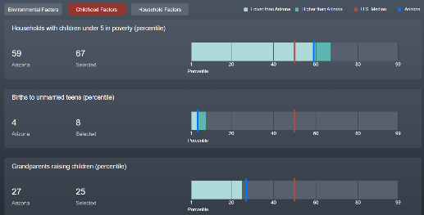
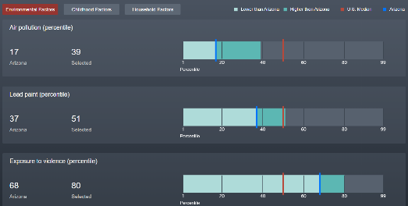
The next screen shows some variables that can impact students and schools but are outside a school’s control. These variables include air pollution (absences due to asthma), lead paint (hurts infant brain development), exposure to violence (ability to pay attention and concentrate in school), the percent of children 0-5 living in poverty, teen births, grandparents raining children, community mobility, lack of health insurance and food insecurity.
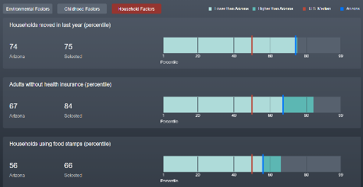
These factors may need to be addressed to ensure students are ready for, and can thrive in, school. For example, several cities are providing pre-school for children, especially poor children, in their cities. This may offset the impact of young children living in poverty. Similarly, programs like Arizona Brainfood address food insecurity by providing children with additional food for the weekends.
The results are percentile ranks comparing the selected area to census tracts around the country, not actual rates. They tell you how your selected area compares to ‘neighborhoods’ (census tracts) around the country. The lower the percentile rank the better, so the more to the left on the slider the better. The national average is 50.
Note that this is not the rate. Measures like births to unmarried teens may be low as a percent of female teens, but have a higher percentile rank because teen births are so low across the country and so many places have even lower rates. What is important to discuss is if that factor is an issue impacting the outcome you want in your selected area.
The key questions to discuss are (1) are these factors having a negative impact on students’ success in our local school(s) and (2) what resources (organizations, programs, etc.) are available that would help us prevent the problem from occurring or that compensate for and offset the negative impacts?

Step 5: How do high school graduation rates and/or college going rates compare to other schools?
Your major question to ask on these screens are how do similar schools compare along the X or Y axis, and are there similar schools one can learn from because they are doing better?

If you choose college going you would click on the College Going Rate icon.

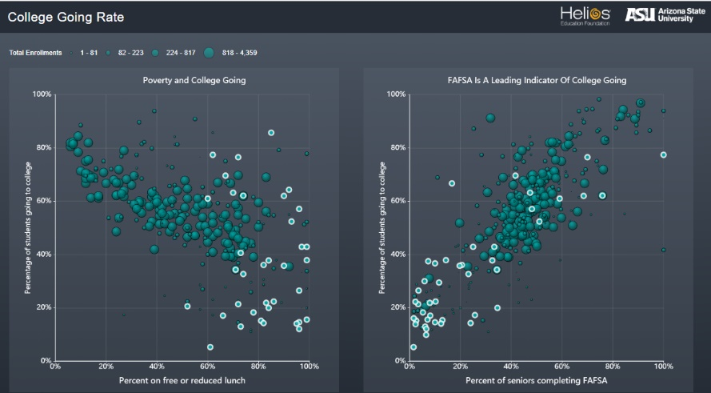
This will bring you to a scatterplot graph showing every high school in Arizona with the high schools in the selected area or group highlighted in white. This allows you to benchmark a school or set of schools against all schools in Arizona.
The first graph shows college going by free and reduced lunch rate, an indicator of student poverty.
Looking at 80-90% poverty for example, we can compare schools with similar poverty. The schools range from over 80% going to college to less than 20%. If these are comparable schools, the schools with lower college going may be able to learn about strategies from the schools with higher rates. Looking horizontally, you can compare schools with similar college going but different poverty rates.
The second graph shows FAFSA completion rates compared to college going rates. Again, you can compare schools with similar FAFSA completion rates by looking vertically, and schools with similar college going rates by looking horizontally.

Why are the latest college going and graduation rates not shown?
The screens are for a specific class (2016, 2017, 2018) and show the census, EPA, college going rate and other data for that class/year. Since the census, civil rights survey, EPA, crime and college going data are released 18-24 months after the latest test scores, the screens do not have all the latest school data for more recent cohorts. Once the census, EPA and college going data are released, the screens will be refreshed with the new data for another cohort (2019, 2020). To enable you to see the latest test scores and graduation rates, we have them posted at decisioncenter.asu.edu/tools… Use the seven screens to understand all the factors impacting graduation and college going and then look to see if the most recent graduation and test score data has significantly changed since then.

One could also look at high school graduation outcomes by clicking on the graduation rate icon. This will allow you to compare schools on graduation rate relative to college going, academic achievement, chronic absences and suspensions.

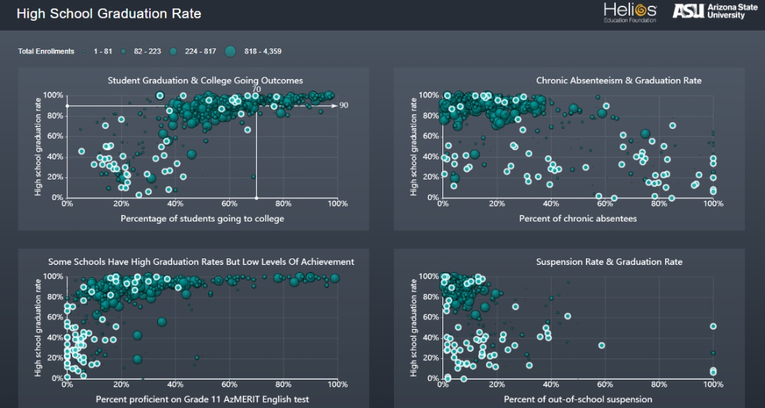
The first graph in the top left shows the state goals for graduation (90%) and college going (70%). The remaining graphs show graduation relative to factors that can impact graduation rates – chronic absenteeism (the percent absent 15 or more days), suspensions (percent of students suspended) and academic skills (proficiency on AzMERIT English Language Arts in 11th grade). We examined the correlation between ACT College and Career Readiness cut points and AzMERIT in schools that gave all students both and the correlation was over .90, so AzMERIT is a good indicator of high academic achievement.

If you go across horizontally from the Y axis you will see schools with similar high school graduation rates but different rates of college going, chronic absenteeism, suspensions or achievement. If you look at it vertically going up from the X axis, you see schools that are similar on the X axis category but differ on high school graduation rates. Many schools have 75-95% graduation rates, so a large number of schools appear bunched together on these graphs.
In the example above, many of the highlighted schools (white bubbles) have low graduation rates, low proficiency rates and high suspension rates. However, there are some that have higher graduation and achievement and lower suspension and absenteeism rates. These results should trigger an effort to learn more about what similar schools are doing that leads to much better outcomes.
Step 6. What do we do to increase student graduations and college going?
In the previous screens you have learned about how schools are doing in college going and graduation, community characteristics that impact college going such as educational attainment and income, and contextual factors that may hinder school achievement. You now know where your school is and have some ideas of what might be done to improve student outcomes.
This screen allows you to make plans to improve college going or graduation rates and to project the impact of the improvements you think you can accomplish.
On your left are ideas to get discussion going. We have provided some research proven strategies to consider. Others may have good ideas that will work in the unique context of your community or organization. You will be answering the questions, what can we do in our area and what impact will it have?
In this example, the participants felt that they could get to the state goal of 70% by implementing a variety of strategies. This is a big improvement – 20%. But it will have a big impact on the students and the community – over 3,000 more students would enroll in college and obtain anywhere from some college education to an advanced degree. This would change their lifetime earnings by over a billion dollars, improving the quality of life for them and for their families. They would also generate $317 million in taxes that governments can spend on schools, parks and other community amenities.
This makes the benefits of improving student outcomes clear for the students and for society.

